**Does Adding Intermediate Algebra as a Prerequisite for Economics Principles Courses Improve Student Success?**

**Steven J. Balassi, Richard H. Courtney, and William Lee**

**Saint Mary’s College of California**

**Introduction**

Teachers and researchers of economics have expressed considerable interest in the relationship between students’ mathematical ability and their success in economics. Interest in this relationship has heightened recently as a result of actions by accrediting agencies requiring colleges to more objectively assess student learning as part of a cycle of continuing educational improvement.

In a possible response to this, the State of California has developed and currently uses a measure of student learning called the “Success Rate” (SR) which is the percentage of students who receive a C or better in a course. The State calculates this SR for all courses taught in the California Community College System.

In the 2009 fall semester, the faculty at Napa Valley College (NVC) implemented a requirement that students enrolling in principles of economics courses must have previously successfully completed a course in intermediate algebra. Another nearby college, Solano Community College (SCC), had not, as of spring 2011, implemented this requirement.

The purpose of this study is to analyze the SR of students in introductory economics courses at these two institutions and determine whether or not the imposition of an intermediate algebra requirement in fact improves student learning in principles of economics courses.

**Literature Review**

Numerous studies have attempted to ascertain factors influencing student learning and performance in principles of economics courses. Typically, educational production functions are employed in which output, measured in terms of economic knowledge, is expressed as a function of productivity inputs. Variables used as productivity inputs include measures of student ability, such as high school GPA and SAT scores; student characteristics, such as gender and ethnicity; as well as instructional techniques employed.

Mathematical ability is frequently hypothesized to be one of the most important determinants of student success in principles of economics courses. Many of the studies examining the determinants of student success have attempted to control for students’ mathematical ability by utilizing a dummy variable to indicate whether or not students had taken a calculus course prior to taking introductory economics or by incorporating a measure of mathematical aptitude, such as students’ scores on the mathematics portion of the SAT. Anderson, Benjamin, and Fuss (1994) found that background knowledge of calculus had a significant positive effect on student performance in introductory economics courses. Durden and Ellis (1995) also found that SAT scores in mathematics had a significant positive effect and the same result was found for students’ experience with calculus. Previously, Williams, Waldauer, and Duggall (1992) found that mathematics SAT scores were a major determinant of student success in introductory economics for all types of exams, excluding essay exams. Brassfield, Harrison, and McCoy (1993) reported that having completed a sequence of courses in business math had a significant positive impact on students’ grades.

While the previous studies all found math skills to be important as a determinant of success in introductory economics courses, the precise skills contributing to students’ success have not been well identified. Ballard and Johnson (2004) used a broader array of explanatory variables to identify which math skills are important for success in introductory microeconomics courses. They examined students’ scores on the math portion of the ACT Assessment Test, whether student had taken a calculus course, whether students had been required to take remedial math, and students’ scores on a test of basic mathematical concepts. They found that “all four measures used have significant effects in explaining performance in an introductory microeconomics course”. However, they also concluded that “quantitative skills are sufficiently multidimensional that no single variable is likely to represent them adequately. The multiple measures of math achievement are relatively independent and are all statistically significant”. In addition, they concluded that “mastery of extremely basic quantitative skills is among the most important factors for success in introductory microeconomics” and that “improvements in student performance may depend on improved mastery of basic algebra”.

This study extends the existing literature by addressing the effect of introducing a prerequisite of intermediate algebra on student success in introductory economics courses

**Background**

Napa Valley College (NVC) is located in Napa, California. It is a member of the California Community College (CCC) system and has about 4,500 full-time equivalent students. Many of NVC’s students take courses that will enable them to transfer to four-year institutions to complete their Bachelor’s degree. Not all courses are transferable from a CCC to a four-year institution. The process of having a course transferable from a CCC to a four-year institution is known as articulation. Articulation agreements are contracts between the CCC’s and four-year institutions. These agreements are in place so students know whether or not the courses they are taking will count when they move from the CCC to a four-year institution. The essence of these agreements is to help students plan and not take unnecessary courses.

NVC offers two economics courses which are transferable to almost all four-year institutions. Both principles of macroeconomics and principles of microeconomics may be taken at NVC and accepted for credit by four-year institutions. Before the 2009 fall semester started, NVC was informed that certain four-year institutions would not allow these two courses to count at their institutions unless NVC added a prerequisite of intermediate algebra. After some discussion and debate, the NVC faculty decided it was in the best interest of their students to add the intermediate algebra prerequisite. Fall 2009 was the first semester students had to have passed an intermediate algebra course before being allowed to enroll in either principles of macroeconomics or principles of microeconomics.

Also included in the study is Solano Community College (SCC), a similar-sized institution located in a county adjacent to NVC that serves an overlapping demographic population. While SCC also offers principles of economics courses, its faculty had not, as of spring 2011, implemented an intermediate algebra requirement as a prerequisite for these courses. This pilot study compares the SR in all economics principles courses taught at both of these colleges each semester from fall 2004 through spring 2011. The goal of the study is to ascertain whether SRs in the principles courses at NVC were affected by implementation of an intermediate algebra prerequisite. Data concerning enrollments and number of students receiving a grade of C or higher in economics principles courses at NVC and SCC were provided by the California Community College System.

**Results and Analysis**

Table 1 shows the SRs in the introductory economics courses for NVC and SCC for the period fall 2004 through spring 2011. The SRs for the two colleges appear to be very similar until fall 2009, the semester when the NVC faculty implemented the intermediate algebra prerequisite. At this time, the SR at NVC increased dramatically while it remained relatively constant at SCC, where no prerequisite requirement was implemented. Table 1 also shows the weighted average of the SR at each college before and after implementation of the prerequisite at NVC in fall 2009. The weighted average SR at NVC improved from 56.6 percent for the period prior to imposition of the prerequisite to 74.6 percent for the period following imposition of the prerequisite. For SCC, the weighted average fell from 54.3 percent prior to fall 2009 to 50.5 percent in the period beginning with fall 2009. Results are shown graphically in Figure 1.

NVC’s weighted average SR following implementation of the prerequisite requirement is statistically higher than prior to implementation of the prerequisite requirement at the 99 percent confidence level while there is no significant difference in the weighted average SR at SCC between the two periods. Moreover, a comparison of means test of the weighted average SR of NVC and SCC during the pre-fall 2009 period showed no statistically significant difference. Using the same test to compare the weighted averages between the two colleges for the period following implementation of the prerequisite shows a statistically significant difference at the 95 percent level of confidence (74.6% for NVC to 50.5% for SCC).

Table 2 shows SRs for both male and female students during the period fall 2004 through spring 2011. Both prior to, and following, implementation of the intermediate algebra requirement in fall 2009, there was no statistically significant difference in the SR for males and females. In addition, the improvement in the SR for males following implementation of the algebra requirement was statistically significant at the 95 percent level of confidence while the improvement for females was significant at the 99 percent confidence level.

**Conclusions, Implications, and Limitations**

Lacking data for other variables that may have affected the results obtained, this pilot study suggests that imposition of an intermediate algebra requirement at NVC did in fact, improve student learning, as measured by the SR in principles of economics courses. However, because of data limitations, the results obtained are subject to further analysis. First, it would be desirable to incorporate additional demographic information about students into the analysis. Changes in demographic characteristics of students taking the economics principles courses prior to and following implementation of the intermediate algebra prerequisite at NVC might account for at least a portion of the improvement in SR observed. While it is possible that some of the improvement in the SR observed at NVC following implementation of the intermediate algebra requirement might be attributed to a significant change in student characteristics, the authors are not aware of any substantial change in student characteristics during that period. Still, incorporating student demographic information would be a refinement that could further support the conclusion that requiring successful completion of an intermediate algebra requirement course leads to increased student success in economics principles courses. Further, inclusion of student demographic information could shed light on whether specific student groups were affected differently by the implementation of an intermediate algebra requirement. However, existing data do indicate that results obtained for males and females were not significantly different.

In addition, the SR (C or better) is not likely to be the most objective or reliable measure of student learning. While some studies use course grades as a measure of student learning (Ball, Eckel and Rojas, 2006) most other research has used standardized test questions, often the Test of Understanding in College Economics (e.g. Lee, Balassi, Courtney 2010) to more objectively measure student success.

It should also be noted that in the fall 2010 and spring 2011 semesters, the SR at NVC exhibited a further increase from the levels achieved in fall 2009 and spring 2010. There is not yet sufficient data to determine if these results are significantly different from the SRs achieved in fall 2009 and spring 2010, or whether the higher SRs will continue. One conjecture is that the improved results reflect some geographical shifting of students between NVC and SRR with weaker students, who had not completed an intermediate algebra course, choosing to attend SCC to complete their economics principles courses, thereby “weeding out” these weaker students and improving the SR at NVC. This process would occur over time, giving rise to the delayed increase in SR at NVC. Such a shift could also have contributed to the decline in the SR at SCC in fall 2010 and spring 2011, even though such declines were not found to be statistically significant.

Finally, prior to the 2009 fall semester, it is likely that some students who enrolled in principles of economics courses at NVC had successfully completed an intermediate algebra course and results for these students are reflected in the SRs calculated for NVC prior to implementation of the algebra requirement. While it seems likely that not all students who completed economics principles courses at NVC prior to the fall 2009 semester had successfully completed intermediate algebra as a prerequisite, because this is not known with certainty, it is not possible to attribute the statistically significant improvement in SR at NVC solely to implementation of the algebra requirement. Overall, however, based on results of this study, implementation of an intermediate algebra prerequisite appears to have considerable merit both for students and institutions in improving student performance in introductory economics courses.

**Table 1- Student Success Rates in Principles of Economics Courses, Napa Valley and Solano Community Colleges, 2004-2011**



Shaded rows represent semesters in which the intermediate algebra prerequite was implemented at NVC.

*SR indicates a student received a grade of C or better.

**Figure 1- Student Success Rates in Principles of Economics Courses, Napa Valley and Solano Community Colleges, 2004-2011**

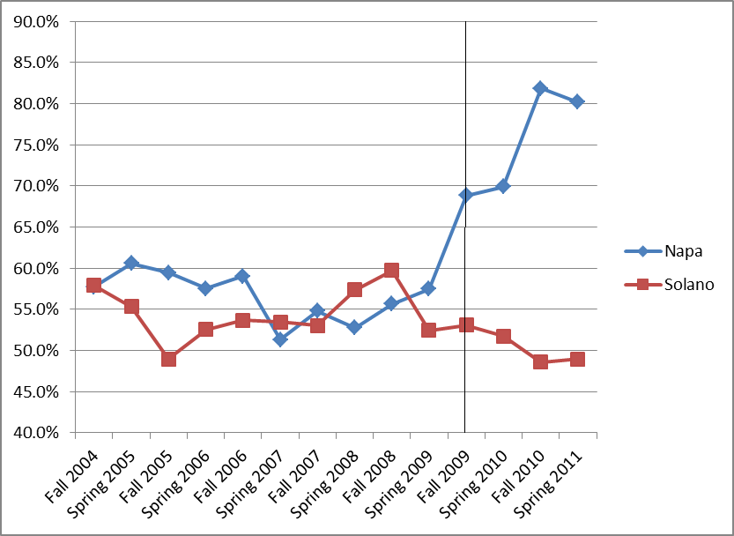

**Table 2- Student Success Rates in Principles of Economics Courses at Napa Valley College, Females vs. Males, 2004-2011**



Shaded rows represent semesters in which the intermediate algebra prerequite was implemented at NVC.

*SR indicates a student received a grade of C or better.

**References**

Anderson, G., Benjamin, D., and Fuss, M. “The Determinants of Success in University Introductory Economics Courses”. *The Journal of Economic Education*. 1994.

Ball, S., Eckel, C., and Rojas, C.  “Technology Improves Learning in Large Principles of Economics Classes:  Using Our WITS”. *American Economic Review*. 2006.

Ballard, C. and Johnson, M. “Basic Math Skills and Performance in an Introductory Economics Class”. *The Journal of Economic Education*. 2004.

Brasfield, D., Harrison, D., and McCoy, J. “The Impact of High School Economics on the College Principles of Economics Course”. *Journal of Economic Education*. 1993.

Durden, G. & Ellis, L. "The Effects of Attendance on Student Learning in Principles of Economics". *American Economic Review*. 1995.

Lee W., Courtney R., and Balassi S. “Do Online Homework Tools Improve Student Results in Principles of Microeconomics Courses?”. *American Economic Review*. 2010.

Williams, M., Waldauer, C., and Duggal, V. "Gender Differences in Economic Knowledge: An Extension of the Analysis". *Journal of Economic Education.* 1992.