Gender Empowerment in 19th Century Sweden: Using Historical Trade Shocks to Assess the Effects of Women’s Economic Empowerment
By Andreas Madestam and Emilia Simeonova∗
The literature examining the impact of unearned income on children’s outcomes suggests that additional income affects children differently depending on who receives it: more income accruing to women improves children’s welfare to a larger extent than extra income given to men (Thomas, 1990; 1994). Less is known about the effect of changes in women’s earnings relative to that of men’s. Schultz (1985) shows that increasing female wages facilitated the fertility transition in 19th century Sweden. Miller and Urdinola (2010) find that rising coffee prices resulted in worse child health in Colombia. Rising prices for goods produced mainly by women (tea) led to higher female survival rates in late 1970s China (Qian, 2008).
This paper studies whether and to what extent changes in relative female earnings affect children’s outcomes differently from changes in male earnings. We examine the impact of exogenous shocks to prices of female and male-specific agricultural goods on the (i) current health of children affected by the shocks and the (ii) lasting effect on children born to the generation affected by the shocks. We exploit the fact that in traditional agricultural societies like 19th century Sweden, dairy-related goods were produced mostly using female labor, while root crops such as oats and forestry were a traditionally male occupation (Heckscher, 1954; Löfgren, 1982; Schultz, 1985; Sommestad, 1987). Using relative male- and female-specific earnings shocks allows us to disentangle effects due to changes in total household income from the impact of gender-specific changes.
The paper explores unexpected changes in relative income by gender induced by export shocks. We study differences in outcomes across areas more suitable for growing the crop subject to the shock to areas that are less suitable, before and after the shock occurred. Information on historical trade shocks and soil suitability measures, available from the Food and Agriculture Organization (FAO), are matched with a unique individual-level dataset based on parish books kept by parish priests in Sweden during the period 1810-1890. The parish data link people across generations and contain demographic information on the universe of individuals born in 37 Swedish parishes between 1810 and 1890.
We find that higher relative male earnings led to more illegitimate births and worse children’s health. On the contrary, increasing women’s relative incomes reduced the illegitimacy rates and improved health outcomes. Gender-specific earnings shocks also have long-lasting and persistent effects. Women whose parents experienced a male-specific positive earnings shock had more children, gave birth to their first child at a younger age, and experienced higher child death rates. We detect a reduction in total fertility among parents who experienced a female-specific earnings shock during childhood and a decrease in the incidence of infant death among their children.
As the export-driven demand shocks are exogenous to the individual household they allow us to isolate the impact of relative wage changes that are independent of parents’ behavior, such as labor supply decisions influenced by household-level unobserved variables. In the 19th century setting of our study most individuals are involved in agriculture; selective fertility due to investments in education or differential selection into the labor force is unlikely. Another appealing feature of the data is that two of the export-driven booms increase relative male earnings while keeping female earnings constant, the third shock lowers relative male earnings, and the fourth increases female earnings. This allows us to identify the effects of gender-specific shocks separately from general household income shocks. Moreover, two of the booms affect male earnings in the same geographic regions but in opposite directions, making it possible to study how a positive and a negative shock affect outcomes independent of location.
Figure 1A plots the evolution of the national Swedish price index for oats, wheat, butter, and timber (Jörberg, 1972) and the evolution of exports of these goods to Great Britain, Sweden’s main trading partner at the time (Fridlizius, 1957). The shaded areas correspond to periods of exogenous export shocks as Great Britain changed its trade policies toward Sweden, primarily by removing tariff barriers. The final plot shows the effects of the opening of grain trade with the U.S. in the 1880s, when cheap U.S. wheat started reaching European markets (Heckscher, 1954). The first oats shock led to a 70% increase in oats’ prices over a 5-year period. Oats exports to Great Britain doubled during those 5 years. The second oats shock raised prices by 40%, while exports to Great Britain increased by 80% in the same period. The two timber booms had similar effects: the national price index increased by 40% and 67%, while exports rose by 200% and 55%, respectively. Wheat and butter prices and exports experienced similar changes, yet butter is notable because pre-1860 Sweden did not export any butter. The right vertical scale in Figure 1 shows the tremendous growth in butter exports in the second part of the 19th century.
Our dataset comprise a number of parishes from several regions. These parishes were not affected by the rise in textile and food processing industries in the latter part of the 19th century, which provided outside opportunities for women not employed in the agricultural sector (Schultz, 1985). Therefore, to the extent that there was negligible mobility to the nascent Swedish manufacturing sector in the cities of Stockholm, Gothenburg and Malmö, our results are robust to changes in the outside female wage.
Data and empirical strategy
The historic parish data are organized at the individual level and include all individuals who resided for more than a year in the 37 parishes born between 1810 and 1890 and their offspring. Parish books record individuals’ dates of birth and death, all marriages, the birth dates for all children, their genders and parity, as well as stillbirths. Inoculation against small pox became compulsory in Sweden starting 1816 and priests were charged with keeping track of who was inoculated (Sköld, 1996). The parish books record vaccination status for all children. A unique personal ID allows us to link spouses, as well children to their siblings, parents, and grandparents. In total, the sample comprises 250,229 individuals at birth, 126,591 men and 123,638 women. Some of them die before age 5 (5,834 boys and 5,322 girls) and these numbers double by the age of 20 (10,825 males and 9,706 females). These individuals are excluded from the long-term and intergenerational analyses.
The first two columns of Table 1 show descriptive statistics of the main outcome variables for the full sample. A child death is defined as a death that occurs before the end of the child’s 5th year – there are 4.5 such deaths per hundred live born children. The illegitimacy rate is slightly higher at 4.8 per hundred children. The smallpox vaccination rate is over 90%, suggesting that the compulsory mandate to vaccinate all infants was successful. The marriage rate of 0.51 is identical to the Swedish average at the time (National Bureau of Statistics, 1969). The age at first marriage and childbearing are also representative for the period. We use soil suitability data from version 3.0 of the Global Agro-Ecological Zones (GAEZ) database (IIASA/FAO, 2012) that we merge with our parish data using GIS. The GAEZ project makes predictions about potential agricultural yields for a given crop in a given location for all the major crop groups. It combines data on soil characteristics, water availability, topography, and climate to predict the productivity of each distinct crop in each location across the world. The parishes are divided into three categories based on the predicted soil suitability for the production of grains such as oats and wheat: completely unsuitable, somewhat suitable, and suitable. About one quarter of the observations come from areas completely unsuitable for grains, another 34 percent are from somewhat suitable areas, and the rest are from regions favorable to growing grains. Similarly, parishes are divided into suitable for logging and related activities if forests cover more than half of their area. We use the livestock variable in GAEZ to divide regions into those appropriate for producing dairy products. These comprise about 30 percent of all individual observations.
Table 1 presents descriptive statistics for the main demographic variables for the full dataset and by region of suitability for different agricultural production. The average child death rate and the illegitimacy rate are lowest in areas that are suitable for dairy production. The vaccination rate peaks in dairy-producing regions, and reaches its lowest level in forested areas. The marriage rate is highest in forested areas, and lowest in dairy-suitable areas. Regional differences in the age at first marriage and childbearing are small. Child health was best in areas where the geographical conditions are favorable to agricultural activities traditionally assigned to women and worst in areas that specialized in male-dominated activities. In the empirical analysis we exploit changes in the returns to female- or male-specific activities within these regions and control for any region-specific time-invariant characteristics.
Our empirical strategy is a difference-in-differences estimation across parishes and time that compares outcomes in parishes with suitable conditions for producing the crop affected by the export shock to those with unsuitable conditions, before and after the shock. Specifically:
$$Y_{ijt}={λExport_Shock}_{t}×D_{j}+α_{j}+τ_{t}+ϕ_{r}×t+{βX}_{i}+ε_{ijt},$$
where $D_{j}$ is an indicator for geographic suitability of parish j for producing the good that was affected by the shock at time t, $α_{j}$ a parish fixed effect, $τ_{t}$ a cohort-specific dummy, $ϕ_{r}×t$ is a region-specific time trend, and X_{i} the person’s gender. Our hypothesis is that the shocks have a positive (negative) impact on goods valued (not valued) by the gender earning the extra income. For example, if women value children’s health we expect λ > 0, while if men do not, λ < 0. The identification does not depend on the assumption that women work only with livestock (and not in the fields) or that men do not work with dairy products. We will underestimate the effect of relative increases in earnings if, in fact, men were involved in women’s work and vice versa. We will also underestimate the effects if the duration of the shocks is shorter (longer) than specified.
We first examine the effect of the trade shocks on the probability that a child is born to a single mother. Throughout the empirical analysis the omitted category are regions unsuitable for the production of the good affected by export shocks. Coefficients are interpreted as differences from mean outcomes between the omitted regions and regions affected by the shocks. The oats and the wheat shocks affect the same regions as soil suitability of oats and wheat is highly correlated. We estimate the effects of these shocks in a single specification. The expectation is that the two types of shocks will work in the opposite direction. The regions affected by the timber and butter shocks are geographically different (see the map in Figure 1B). Columns 1-4 in Table 2 present the results we obtain by using male-specific (columns 1 and 2) and female-specific (columns 3 and 4) relative earnings shocks. A male-specific earnings boom increases the illegitimacy rate by approximately 30% (1.6 percentage points from a mean of 4.8%). Similar to Schultz (1985) we find no significant effects of male-specific earnings shocks on the overall contemporaneous fertility rate (not shown). Thus, the rising illegitimacy rate reflects a shift in the composition of births. Children born to single mothers in the 19th century were at a significant disadvantage throughout their lives compared to children born to married parents. Our results suggest that the average child born during periods of higher male-specific earnings had lower wellbeing during their lifetime. The contrary is true for children born during periods of high female earnings potential. The point estimates are of the opposite sign and of very similar magnitude in columns 3 and 4. We next study how export booms affect the probability of child death before age 5. Again, male-specific and female-specific shocks work in the opposite direction. Male-specific shocks result in higher child mortality rates. Higher female earnings power reduces these rates. These patterns repeat when we consider the vaccination rate. Relatively more powerful women improve children’s health.
The lower panel of Table 2 presents the effects of exposure to earnings shocks during childhood on the age at first childbearing, total fertility, and the child mortality rate of the next generation. Treatment is defined as the number of years of exposure to the shock during childhood (until the individual turns 15). The coefficients estimate the marginal effect of experiencing an extra year of the shocks. Average exposure in the sample is approximately 1 year; among individuals exposed for at least one year the average is 6 years. The sample is restricted to people who are born during the sample period 1810-1890 and whose children’s outcomes are observed.
Rising male relative earnings decrease the age of first childbearing, shifting births from women’s 30s to their 20s. Interestingly, positive female shocks work in the same direction, even though the point estimate is not precise enough draw any strong conclusions. The last rows in Table 2 reports the coefficient estimates from models of total fertility and child mortality in the next generation. Parents who grew up during periods of male-specific positive earnings shocks have more children, and these children are more likely to die before the age of 5. On the contrary, those who experienced positive female-specific earnings shocks during childhood have fewer children and are less likely to lose a child. For example, spending 7 years of childhood during a male-specific positive shock increases child mortality by 0.7 percentage points, while a female-specific positive shock of the same duration decreases it by double that magnitude (31% percent at a mean of 0.045). This is clear evidence in favor of the quality-quantity tradeoff: parents affected by female-specific earnings shocks during childhood have fewer children but invest more in them. The effects on child mortality of the next generation are similar in the samples of men and women; boys who grow up during female-specific positive earnings shocks are affected similarly to girls. The findings are consistent across the immediate and the long-term outcomes–positive shocks to relative female earnings are beneficial for the health of the current and future generations. This evidence can be interpreted in favor of intergenerational transmission of health - worse mother’s health during childhood is predictive of bad health for her children. It is also consistent with the notion that the grandmother’s earnings potential during the mother’s childhood affects the education of the mother, resulting in better health for her children (Duflo, 2003). While the data do not allow us to distinguish between these two mechanisms, they speak strongly in favor of the non-unitary model of intra-household bargaining (Lundberg and Pollak, 1993).
Concluding remarks
This paper makes use of a unique dataset from 19th century Sweden and a set of international trade shocks to identify the effects of changes in gender-specific earnings on children’s short- and long-term wellbeing. The effects of international trade shocks are not gender-neutral: positive shocks to women’s earnings are beneficial for children’s welfare; the opposite is true for positive shocks to men’s earnings.
Table 1: Descriptive statistics of main outcome variables; standard deviations in parentheses
 | Full sample |  | Good wheat conditions |  | >50% forest |  | Good cattle conditions
 | N | Mean | N | Mean | N | Mean |  | N | Mean
Child death | 248781 | 0.045[.20] | 102720 | 0.040[.19] | 119280 | 0.051[.22] |  | 59002 | 0.036[.18]
Illegitimate birth | 250229 | 0.048[.22] | 103181 | 0.038[.19] | 120078 | 0.050[.22] |  | 59224 | 0.034[.18]
Child vaccinated | 250229 | 0.914[.28] | 103181 | 0.945[.23] | 120078 | 0.924[.26] |  | 59224 | 0.95[.21]
Married | 150266 | 0.51[.50] | 70501 | 0.4[.49] | 69019 | 0.58[.49] |  | 41594 | 0.38[.48]
N children | 150266 | 2.0[2.7] | 70501 | 1.4[2.4] | 69019 | 2.5[3.2] |  | 41594 | 1.3[2.26]
Age married | 82447 | 27.2[5.6] | 29334 | 27 [5.56] | 43141 | 27.1[5.5] |  | 16557 | 27[5.46]
Age at 1st birth | 77022 | 27.26[5.2] | 28115 | 27.17[5.21] | 39700 | 27.2[5.1] |  | 15810 | 27.3[5.2]
Child death | 58743 | 0.05[.21] | 21670 | 0.04[.20] | 29169 | 0.052[.22] |  | 12244 | 0.04[.19]

Table 2: Trade shocks and child wellbeing#
Shock | Timber | Oats and Wheat## |  |  |  | Butter
 | (1) | (2) |  | (3) |  | (4)
 | Concurrent effects
Illegitimate birth | 0.0157** | 0.0183*** | -0.0078 |  |  |  |  | -0.0155***
 | (0.00650) | (0.00636) | (0.006) |  |  |  |  | (0.00496)
Child death | 0.0193* | 0.0223*** | -0.010** |  |  |  |  | -0.0257**
 | (0.0103) | (0.008) | (0.0045) |  |  |  |  | (0.0115)
Child vaccinated | -0.0346*** | -0.0392*** | 0.0231 |  |  |  |  | 0.0106
 | (0.00972) | (0.00984) | (0.0172) |  |  |  |  | (0.0179)
Obs | 250,229 | 250,229 |  |  |  |  |  | 195,201
 | Long-term effects
1st child age | -0.015** | 0.001 |  |  | -## |  | -0.032
 | (0.006) | (0.008) |  |  | - |  | (0.019)
N children | -0.001 | 0.01** |  |  | - |  | -0.019***
 | (0.004) | (0.004) |  |  | - |  | (0.006)
Child death | 0.001** | 0.001 |  |  | - |  | -0.002**
 | (0.0005) | (0.001) |  |  | - |  | (0.001)
Obs | 44,924 | 44,924 |  |  | - |  | 35,566
*Significant at the 10%; ** 5%; ***and 1% level; #all specifications include parish of birth and cohort fixed effects and region-specific linear trends. We do not report dummy estimates for the middle range of grain suitability in the interest of space. SEs are clustered on the parish of birth level, reported in parentheses under the coefficient estimate; ##The sample period is too short (last cohort born in 1890) to analyze the long-term effects of the wheat shocks

Figure 1A: Swedish Exports, Export Shocks, and National Price Indices | Figure 1B: Suitability Indices
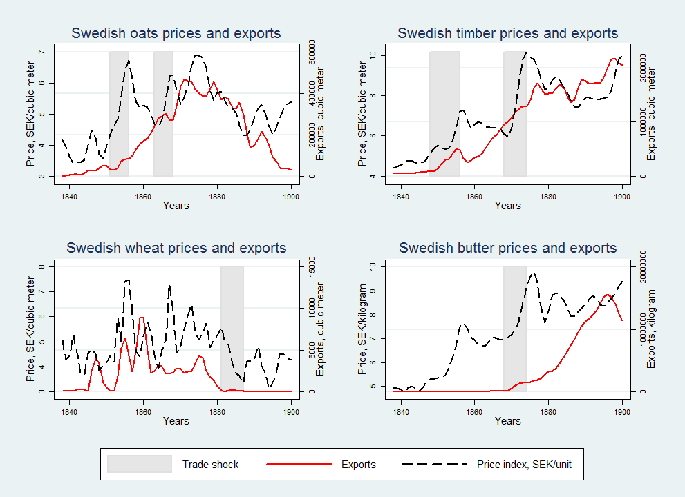 | 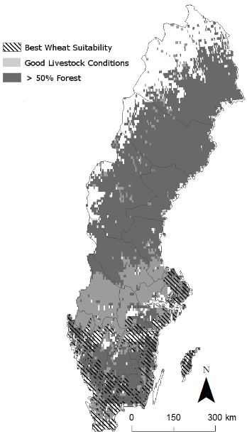

References
Fridlizius, G., (1957), “Swedish Corn Export in the Free Trade Era: Patterns in the Oats Trade 1850-1880”, CWK Gleerup, Lund
National Central Bureau of Statistics, (1969), “Historical Statistics of Sweden Part 1. Population. 1720-1967” KL Beckmans Tryckerier AB, Stockholm
Nunn, N. and N. Qian, (2011), "The Potato's Contribution to Population and Urbanization: Evidence from a Historical Experiment," Quarterly Journal of Economics, 126(2): 593-650
Sköld, P., (1996), “From Inoculation to Vaccination: Smallpox in Sweden in the Eighteenth and Nineteenth Centuries,” Population Studies, 50(2): 247-262

Jörberg, L., (1972), “A History of Prices in Sweden” Vol. 1-3, Lund, Sweden, CWK Gleerup
Schultz, T. P., (1985), “Changing World Princes, Women’s Wages and the Fertility Transition: Sweden 1860-1910,”, Journal of Political Economy, 93(6): 1126-1154
Heckscher, E., (1954), “An Economic History of Sweden” Harvard Univ Press, Cambridge, MA
IIASA/FAO, (2012), Global Agro‐ecological Zones (GAEZ v3.0). IIASA, Luxemburg, Austria and FAO, Rome, Italy
Löfgren, O., (1982), “Kvinnfolksgöra - om Arbetsdelning i Bondesamhället”, Kvinnovetenskaplig Tidskrift, 3: 6-14.
Staffansson, J.-Å., (1995), “Swedish Butter. Production, Consumption, and Foreign Trade 1861-1913,” Lund University Press, Lund
Söderlund, E., (1952), “Swedish Timber Exports 1850-1950,” Almqvist och Wiksells, Uppsala
Sommestad, L., (1987), “Från mejerska till mejerist,” Historisk tidskrift, 107: 80-95
Thomas, D., (1990), “Intra-Household Resource Allocation: An Inferential Approach”, Journal of Human Resources, 25 (4): 635-664
Thomas, D., (1994), “ Like Father, like Son; Like Mother, like Daughter: Parental Resources and Child Height”, Journal of Human Resources, 29 (4): 950-988
Qian, N (2008),“Missing Women and the Price of Tea in China: The Effect of Sex-Specific Earnings on Sex Imbalance,” Quarterly Journal of Economics, 123 (3): 1251-1285
Miller, G. and P. Urdinola, (2010), “Cyclicality, Mortality, and the Value of Time: The Case of Coffee Price Fluctuations and Child Survival in Colombia,” Journal of Political Economy, 118(1): 113-155
Lundberg, S. and R. Pollak (1993) “Separate Spheres Bargaining and the Marriage Market” Journal of Political Economy, 101 (6): 988-1010

∗* Madestam: Department of Economics, Stockholm University (email: andreas.madestam@ne.su.se); Simeonova: Department of Economics, Tufts University, Princeton and NBER (email: emilia.simeonova@gmail.com).
The oats’ shocks, in 1851-56 and in 1863-68, followed after the repeal of the Corn Laws in Great Britain in 1849, with Sweden accounting for 36 % of Britain’s total oats imports in the mid-1860s (Fridlizius, 1957). The increase in demand for Swedish timber, in 1848-56 and in 1869-74, was a result of the lowering of British timber tariffs in 1842 and 1851 and of an international demand boom in the late 1860s (Söderlund, 1952). Finally, Swedish butter exports to Great Britain took off in the latter half of the 1860s because of rising British incomes (Staffanson, 1995).
From the Sundsvall region: the town of Sundsvall, Alnö, Attmar, Galtström, Hässjö, Indal, Lagfors bruk, Ljustorp, Lögdö, Njurunda, Sättna, Selånger, Skön/Skönsmon, Svartvik, Timrå, Tuna, Tynderö. From the Skellefteå region: the town of Skellefteå, and the parishes of Jörn and Norsjö. The Linköping region is represented by: Björsäter, Grebo; Kaga, Kärna, Landeryd, Rappestad, Rystad, Slaka, Vikingstad, Vårdsberg, Värna, Sant Lars. The parishes of Fleninge, Gullholmen, Nedertorneå, Svinnegarn, and Trosa are also included for a total of 37 parishes.
We tested for differential mobility between regions and found no evidence that such selective migration took place
The GAEZ predictions are available for each 5 arc-minute grid cell. See Nunn and Qian (2009) for a recent application and a more detailed description of the data. GAEZ is available for different scenarios in which different levels of input are applied. We use the high input option and allow for irrigation, as there is little useful variation to be explored in the intermediate and low-level use of inputs.
We use the count of cattle in the year 2000 and assume that the environmental conditions that make some areas suitable for cattle have not changed. Areas with > 2000 cattle /km² are defined as suitable to dairy production.
One concern is that the price hikes reduced consumption of the exported goods. However, none of the commodities studied were staple foods in 19th century Sweden. Also, any decrease in consumption would have been gender-neutral, and thus unlikely to bias our estimates.
We tested whether the effects on child health are isolated in the group of illegitimate children. We found no evidence that the effects of the shocks differ between children born to single mothers and children born to married couples. In addition, we find no significant gender differences in the effects of the shocks.
This result confirms Schultz’s findings (1985) in an individual level panel dataset. The results are very similar when we estimate separate models for men and women, so we pool the two samples and control for gender in the analysis. We find no significant effects of any type of shock on the age at first marriage for either gender.
In 19th century Sweden a newly married couple established a separate household with independent land holdings
When studying total fertility we use the sample of cohorts for whom we observe fertility at least until age 35

